

Sri Lanka Institute of Information Technology

**Online Buying N Selling System**

Information Technology Project Management (IT 3030)

2019

**Project ID: Group 405-G7**

Final Project Report

Submitted By:

* + - * + IT 17063769 Mahawatta D.K.
        + IT 17114004 Thalagahagedara T.M.S.S.B.
        + IT 17097734 Abimani R.M.K.C.
        + IT 17106566 Wijesinghe D.S.D.
        + IT 17103114 Tissera W.S.

Table of Contents

**1. Members’ Details and Work Lord1**

**2. Clickable Link1**

**3. Functional / Non-Functional Requirement2**

**4. SE methodologies/Methods2**

5. Diagram Description

5.1 Onion Diagram3

5.2 Activity Diagram3

**5.3 Use Case Diagram3**

**5.4 Overall Architecture3**

**5.5 Class Diagram (Other diagrams) 3**

**6. Appendix**

6.1 Appendix 1: Onion Diagram4

6.2 Appendix 2: Activity Diagram5

**6.3 Appendix 3:** **Use Case Diagram6**

**6.4 Appendix 4:** **Overall Architecture7**

**6.5 Appendix 5:** **Class Diagram (Other diagrams) 8**

**6.6 Appendix 6:** **ER-Diagram (Other diagram) 9**

**6.7 Appendix 7:** **Gantt chart 10**

1. ***Members’ Details and Workload Allocation***

|  |  |  |  |
| --- | --- | --- | --- |
| **Description of Function** | **Registration Number and Name of Developer** | | **Role** |
| **IT Number** | **Name** |  |
| * User Login |  |  |  |
| * User Login Validation |  |  |  |
| * User Registration | IT17103114 | W.S.Tissera | User Management |
| * User Details View |  |  |  |
| * Update and Delete Users |  |  |  |
|  |  |  |  |
| * Add Post |  |  |  |
| * View Post | IT17097734 | R.M.K.C. Abimani | Inventory |
| * Update Post |  |  |  |
| * Delete Post |  |  |  |
|  |  |  |  |
| * Add Payment Settings |  |  |  |
| * View Payment Details | IT17114004 | T.M.S.S.B thalagahagedara | Payment |
| * Update details |  |  |  |
| * Delete payment Details |  |  |  |
|  |  |  |  |
| * Add Shipping Companies |  |  |  |
| * View Companies | IT17106566 | D.S.D.Wijesinghe | Shipping Management |
| * Update Companies Details |  |  |  |
| * Delete Companies |  |  |  |
|  |  |  |  |
| * Admin Login |  |  |  |
| * Admin Login Validate |  |  |  |
| * Add Items to Cart |  |  | Cart and Orders |
| * View Cart Items | IT17063760 | D.K.Mahawatta |  |
| * Update Cart Items |  |  |  |
| * Delete Cart Items |  |  |  |

1. ***Clickable Link (VCS repo) -***  <https://github.com/dilummahawatta/pafProject.git>
2. ***Requirements***

|  |  |  |  |
| --- | --- | --- | --- |
|  | Functional Requirement | Non- Functional Requirement | Technical Requirement |
| Order and Cart | Add products to the cart and Update, Delete Products to the cart | Scalability**,** Capacity**,** Availability**,** | High reliability |
| Payment | Set payment settings for the product and Update, Delete Payments. | Performance**,** Response time**,** Security and privacy | Accessibility  User friendly |
| Inventory | Add Product to the system and Delete, Update product details as admin. | Security and privacy**,** Availability**,** Scalability**,** Capacity | Adaptability |
| User Management | Login**,** Logout, Register members, View member’s details and Update, Delete details. | Environmental**,** Data Integrity**,** Usability**,** High security | High performance |
| Shipping Management | View shipping companies**,** Add shipping companies and Update, Delete. | Availability**,** Recoverability**,** Serviceability. |  |

1. ***SE Methods/Methodologies***

**Agile Model**

**Description**

Agile SDLC model is a combination of iterative and incremental process models with focus on process adaptability and customer satisfaction by rapid delivery of working software product. Agile Methods break the product into small incremental builds. These builds are provided in iterations.

**The usage**

* Iterative process of plan, develop and deploy to meet the changing client needs while ensuring fast development of prototypes Software development technologies and tools are well-known.
* Set of engineering best practices that allow for rapid application development and delivery.

**Advantages**

* Customer satisfaction by rapid, continuous delivery of useful software.
* People and interactions are emphasized rather than process and tools. .
* Customers, developers and testers constantly interact with each other.

**Disadvantages**

* In case of some software deliverables, especially the large ones, it is difficult to assess the effort required at the beginning of the software development life cycle.
* Lack of emphasis on necessary designing and documentation.

1. ***Diagrams Description***

5.1 Onion Diagram - In a few circles, the onion chart can display online purchase and sales system layers. In the 1st inner circle, it shows the stakeholders very close to the product. What would be the new system or process? Stakeholders are composed of project manager, developer, QA, etc. The second inner circle shows the stakeholders whose work changes when the solution is defined as end user. In this diagram, users are registered users, registered buyers, and so on. The innermost circle represents the system, the next circle captures all users of the system. The outer circle includes all other employees in the organization who depend on the system. Last circle or fourth circle: external stakeholders such as customers, regulators, government, suppliers (Refer Appendix 1)

5.2 Activity Diagram- First user want to register is re-type password incorrect then it says please check password then after registration user should give username and password to log to the system then user can see all products and if user want get items then user should click add to cart user can see available shipping companies. User can update delete cart if user delete items from the cart it says are you sure message then user have to set payment of specific item. Then as an admin can update delete shipping companies and products. (Refer appendix 2)

5.3 Use Case Diagram- A use case diagram for the online buying and selling system consisting mainly of five players. They are customer, salesman, system administrator and Transport Company. The customer can register and log into the system, manage the cart, view product details by selecting a category. In addition, the user can add items to the cart and make the payment. As an admin, log into the system. After connecting to the system, he can update the product information. The seller can add new products to the system, update the products and also delete or delete products from the system. In addition, the seller can view the details of the order and manage the details. The shipping company shipping the products and handles the shipping request. (Refer appendix 3)

5.4 Overall Architecture - User login to the system. Then, through the API, try creating user accounts using account services. Users are mainly administrators, buyers and suppliers. A database stores all account details of all users. The buyer and the vendor use the product inventory service and the information stored in the product inventory database. Other users use the ordering service, the payment service and the shipping service of the buyer. (Refer appendix 4)

5.5 Class Diagram- There are four classes in the diagram. They are Customer, Category, Admin, Product, Order Details, Shipping, Payments, and Orders. Many Customers can have many Products. Therefore Customer Class and Products class have many to many. Also many Products can have many Customers. Customer class has a composition relationship with the order detail class. Order details cannot exist without the Customer class. Category can have many Products. The product cannot exist without Category and Supplier.

# Appendix

6.1 Appendix 1: Onion Diagram

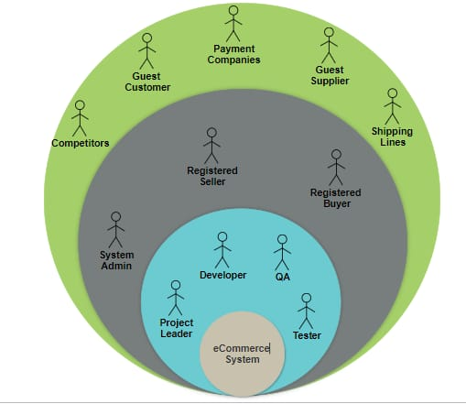

6.2 Appendix 2: Activity Diagram

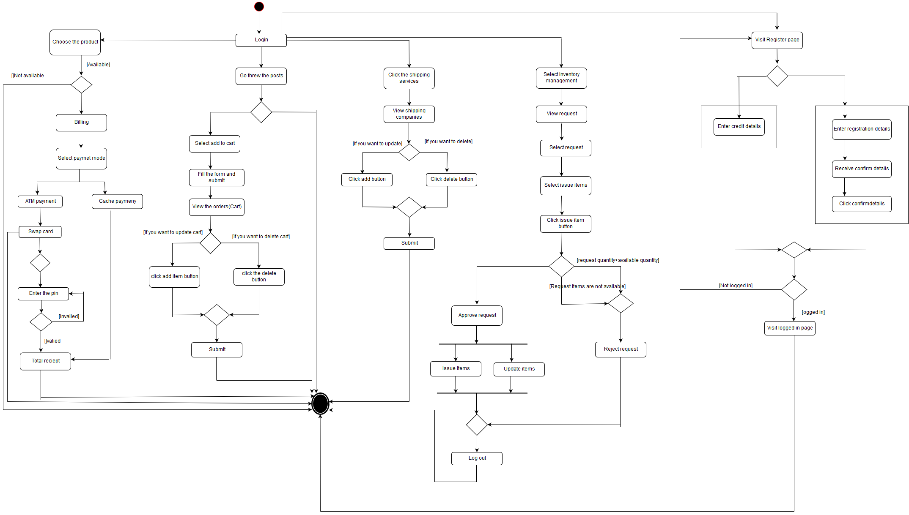

6.3 Appendix 3: Use Case Diagram

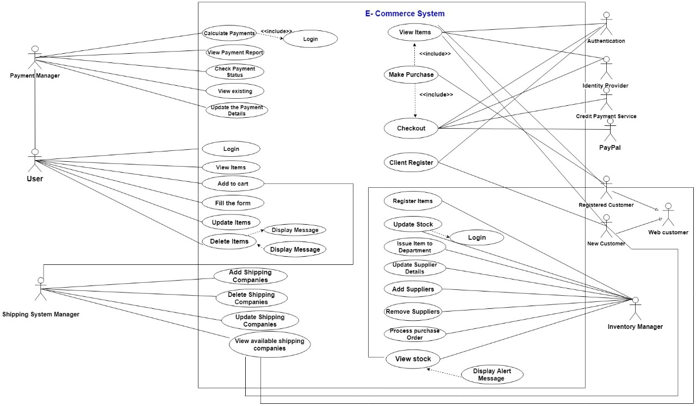

6.4 Appendix 4: Overall Architecture

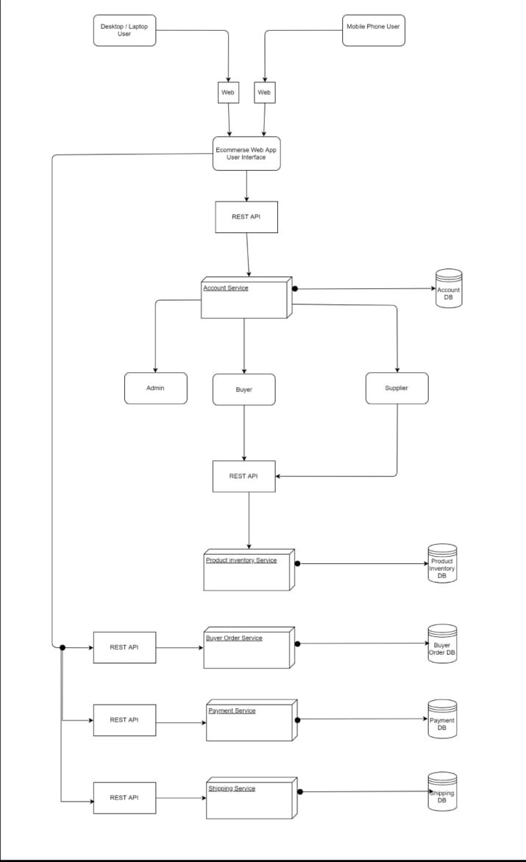

6.5 Appendix 5: Class Diagram (Other Diagram)

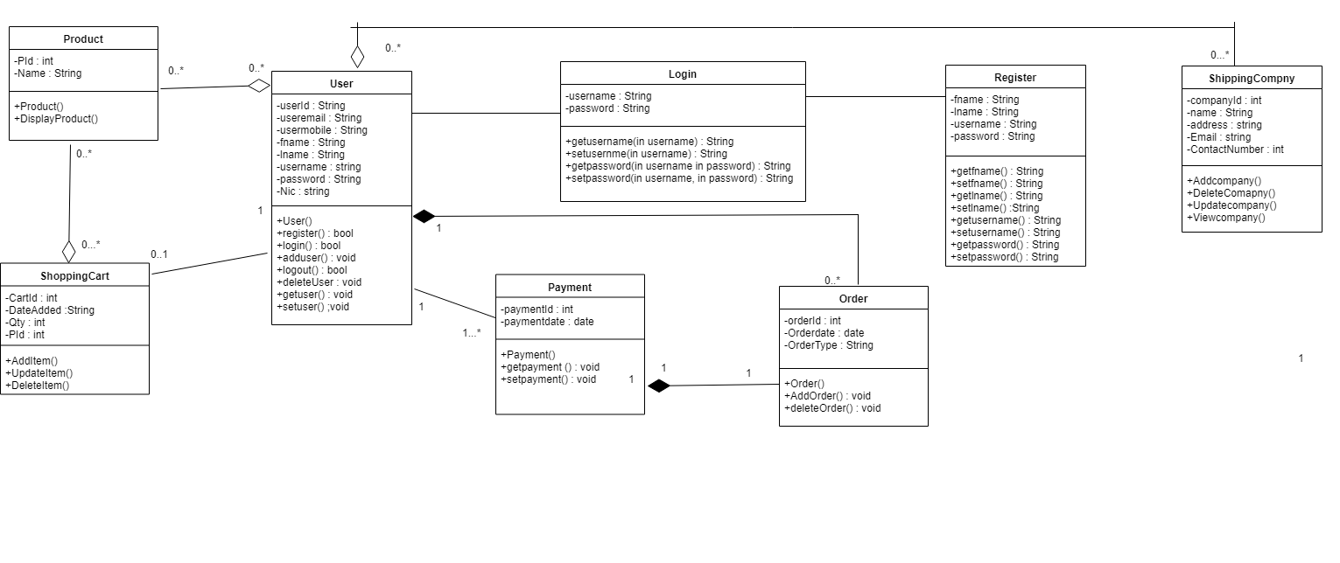

6.6 Appendix 6: ER-Diagram

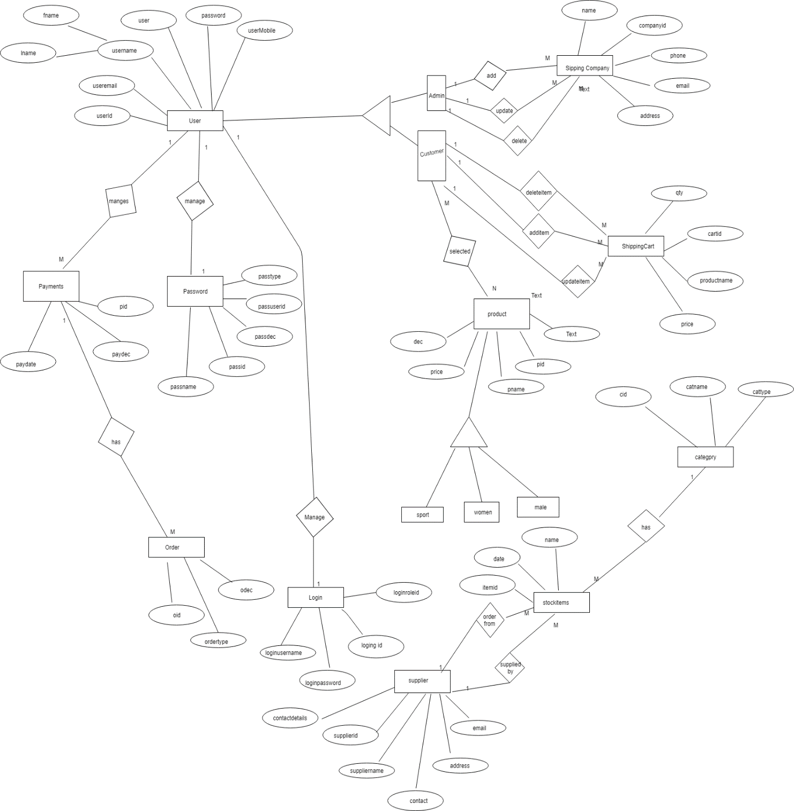

6.7 Appendix 7: Gantt chart

